EXPERIMENT – 2
Create a simple cloud software application for Flight Reservation System using any Cloud Service Provider to demonstrate SaaS.
AIM: To create and provide a simple cloud-based software application for Flight Reservation System using Zoho Creator to demonstrate the Software as a Service (SaaS) model.
PROCEDURE:
- Open a web browser and go to Zoho Creator website.
- Create a Zoho account and log in.
- Click on Create Application and select From Scratch.
- Choose Blank App and provide the application name as Flight Reservation System.
- Create a form named User Details and add fields such as Name, Phone, Email and Address.
- Create another form named Ticket Booking and add fields such as Name, Passport ID, Visa Number, Date, Time, Departure Location and Arrival Location.
- Create a Sub form to select seating and add fields such as Class and Seat Type.
- Mark the necessary fields as mandatory.
- Save the completed form and alter the visual themes.
- Configure user access and sharing settings to allow multiple users to use the application.
- Save the application and generate the application URL.
- Access the application through the URL using any web browser.

OUTPUT:
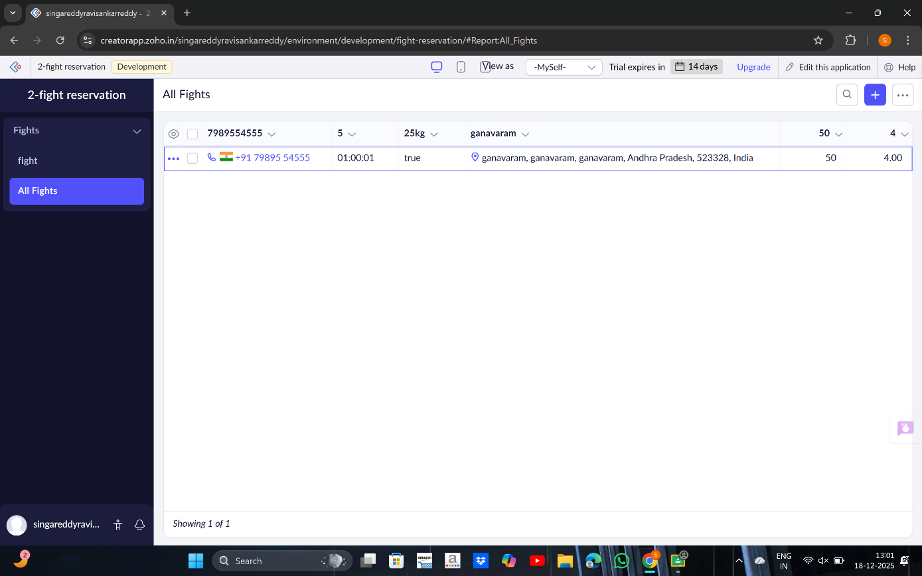

RESULT:
A cloud-based Flight Reservation System application was successfully created and deployed using Zoho Creator. The application is accessible through a web browser without installation, and users can Sign up and Book tickets online, thereby successfully demonstrating the Software as a Service (SaaS) model.

